Chara Kolokytha

Matisse, Henri [Emile Benoît] (1869-1954)

Henri Matisse is a key figure in French modernism and is considered to be the most influential colourist of twentieth-century art. A French painter, sculptor, and printmaker, Matisse studied painting in Paris at the École des Beaux Arts under Gustave Moreau, the École des Arts Décoratifs and the Académie Julian under W.A. Bouguereau. Matisse’s early paintings demonstrate a dark, sombre, and dull palette and a naturalist approach to his selected themes (La liseuse, 1894). This progressively gave way to more vivid pure colours (Still Life with Oranges, 1899; Académie bleue, 1899-1900) and impressionist execution (Study of a Nude, 1899). In 1903, Matisse began to use intense pure colours, marking a break with both naturalist and impressionist traditions (Portrait d’André Derain, 1905). He inaugurated a new style that contemporary critics named Fauvism (Le Bonheur de vivre, 1905-6). From the early 1920s, Matisse enjoyed a worldwide reputation, being famous both for his masterfully coloured compositions and for the joyful atmosphere of his works, which became the hallmark of his overall artistic production. Works by Matisse can be found in most museums of modern art around the world in addition to primary displays at the Museum Matisse in Nice and in his birthplace, Le Cateau Cambrésis.

Painting

The influence of Paul Cézanne is evident in the artist’s early work and, in particular, through his conception of space, light and form. Persian miniatures and Japanese prints influenced Matisse, and he studied African art with great interest (see, for example, Nu debut, 1907) at the end of the first decade of the century. His interior spaces (Harmony in Red, 1908) and painted odalisques (Reclining Odalisque, 1926) owe much to his admiration for the Asian art and textiles then exerting considerable influence over Eurpoean decorative artists. Matisse’s art also has Symbolist overtones (La Danse, 1910) implying the influence of his tutor, Gustave Moreau.

In the mid-1930s, the artist attempted to simplify his technique; subsequently, he introduced the so-called ‘paper cut-outs’ (papiers découpés), which he used in order to replace the drawing on the coloured surfaces of his works, resulting in a collage-like composition. In collaboration with the Parisian art critic and editor, Tériade (Stratis Eleftheriades), he perfected this technique facilitating the reproduction of these works in several luxurious livres d’artistes (artists’ books) published after the end of the Second World War. The most representative illustrated book of Matisse’s mature style is Jazz (1947), edited by Tériade, which reproduces about one hundred colour prints.

Sculpture

Matisse’s sculptural work, enumerating approximately eighty pieces, is considerably overshadowed by his paintings, but played an important role in the shaping of his painterly style. The artist admitted that he sculpted as a painter and used this medium to better understand pictorial problems during the creative process. Matisse created over half of his sculptural works from 1900 to 1909. Subsequently, his production became intermittent. His interest in sculpture is evident in his relatively late decision to attend courses at the Ecole communale de la ville de Paris, producing a copy after the cast of Jaguar Devouring a Hare (1899-1901) by Antoine-Louis Barye. This piece was Matisse’s first and only work that treated a violent and bestial scene characterised by strenuous movement. Although denying Rodin’s immediate influence on his work, the artist purchased a Rodin plaster bust as early as 1899. Matisse also hired an aged female model that formerly posed for Rodin to pose for The Serf (1900-3).

The spiralling rhythm of Madeleine I and II (1901 and 1903) reveals his admiration for the arabesque. Despite his interest in primitive art – African carvings in particular – Matisse linked his sculptural production to the Renaissance tradition. The artist, however, differentiated his style from that of Aristide Maillol since he was no longer concerned with the volume of his creations, a fact that is also evident in his paintings. Unlike Rodin, he avoided loading his works with literary connotations. Most of Matisse’s sculptures, in principle, lack the element of narration as well as the sense of movement.

Matisse’s casts demonstrate the use of ancient techniques such as sand moulding and lost wax casting. Following his painting style, the artist’s sculptural forms were considerably simplified after 1916. The most transparent demonstration of his evolution in style is to be traced in the Back (I-IV) plaster reliefs elaborated between 1909 and 1930. This monumental scale series was subsequently cast in bronze, showing the back view of a woman concealing her face. Matisse’s interest in relief sculpture is a demonstration of his treatment of sculpture from a painter’s perspective.

Graphic Work

Matisse produced an important number of prints and drawings throughout his career. Most of them constitute commissioned works by several publishers (Skira, Tériade, Maeght) and were used to illustrate a series of collectors’ books. His most important book illustrations are mostly for works of poetry, including Les Jockeys Camouflés by Pierre Reverdy (drawings, 1918), the Poésies by Stéphane Mallarmé (etchings, 1932), James Joyce’s Ulysses (engravings, 1935), the Lettres religieuses portugaises de Mariana Alcoforado (lithographs, 1946), Charles Baudelaire’s Les Fleurs du Mal (xylographs, etchings, photo-lithographs, 1947), and Poèmes de Charles d’Orléans (colour lithographs, 1950).

Decorative - Monumental Work

Matisse’s earliest large-scale commissions include the two decorative panels, The Dance [La Danse] and Music, that he elaborated in 1909-1910 for the Russian collector Sergei Shchukin. In the early 1930s, the artist was commissioned by the American collector Albert Barnes to create a second version of The Dance as a mural placed above the windows of the main gallery of the Barnes Foundation in Merion. Later in his life, the most important decorative projects that he undertook include his monumental works for the decoration of the interior of the Dominican Chapel of the Rosary in Venice, elaborated between 1948 and 1951. The same year, Matisse produced a number of works for the decoration of the villa Natasha (Saint-Jean-Cap-Ferrat), belonging to Tériade – notably Les Poissons chinois (stained glass, 1951) and Le Platane (mural, 1952).

Illustrations
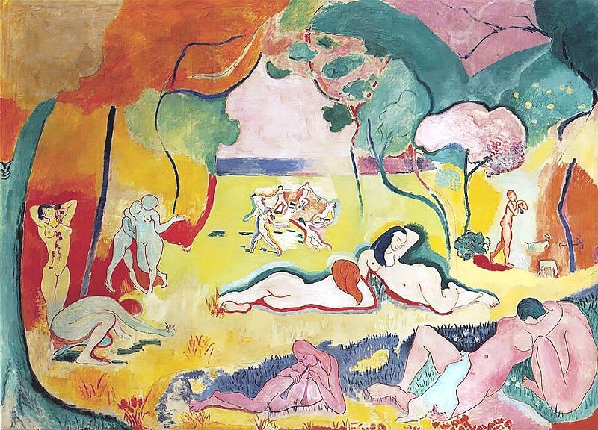

Le Bonheur de vivre (The Joy of life), oil on canvas, 1905-6, Barnes Foundation, Merion.
http://en.wikipedia.org/wiki/File:Bonheur_Matisse.jpg

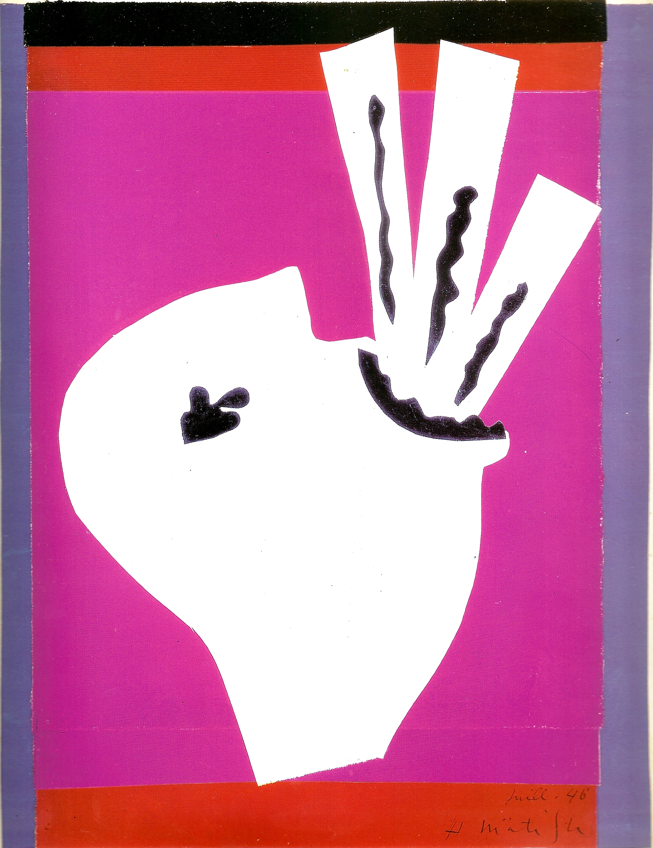

Henri Matisse, L’Avaleur de sabres, 1943-44, print from Jazz, Paris, Tériade, 1947.

Useful Links

Official site of the Museum Matisse, Nice:
http://www.musee-matisse-nice.org/
Official site of the Museum Matisse, Le Cateau Cambrésis:
http://museematisse.cg59.fr/fr/Accueil/tabid/40/Default.aspx

Films

Henri Matisse (1946) documentary, directed by Francois Campaux (French)
Henri Matisse ou le talent du Bonheur, (1960) documentary, directed by Marcel Ophuls (French)
Henri Matisse dans le midi (1996) Omega films, directed by Charles de Lartique (French)

References and further reading

Barr, A. H. (1951) Matisse: his Art and his Public, New York, The Museum of Modern Art.

Duthuit, C., Duthuit-Matisse M. (1983) Henri Matisse: Catalogue raisonné de l’œuvre gravé, Paris, C. Duthuit Editeur.

Flam, J. (1993) Matisse: The Dance, Washington, National Gallery of Art.

Flam, J. (1996) Matisse on Art, Berkeley, University of California Press.

Weiss Bock, C. C. (1996) Henri Matisse: A Guide to Research, London and New York, Routledge.

Szymusiak, D., Di Crescenzo C. (1997) Matisse et Tériade, exh. cat. Musée Matisse, Le Cateau Cambrésis, Anthèse.

O’Brian, J. (1999) Ruthless Hedonism: The American Reception of Matisse, University of Chicago Press.

Kosinski, D.M., Fisher J.M., Nash, A. (2007) Matisse: Painter as Sculptor, Yale University Press.

Henri Matisse: notes d’un peintre (2012) exh. cat. Paris, Centre Pompidou.

Rabinow, R., Aagesen, D. (2012) Matisse: In search of true painting, exh.cat. New York, Metropolitan Museum of Art.

Cronan, T. (2013) Against Affective Formalism: Matisse, Bergson, Modernism, University of Minnesota Press.

McBreen, E. (2013) Matisse’s sculpture: the pinup and the primitive, New Haven, Yale University Press.

